Adding Indexes
The more data you include in your tables, the more you need indexes to help Microsoft Access search your data efficiently. An index is simply an internal table that contains two columns: the value in the field or fields being indexed and the location of each record in your table that contains that value. Let’s assume that you often search your Customers table by city. Without an index, when you ask Access to find all the customers in the city of Bellevue, Access has to search every record in your table. This search is fast if your table includes only a few customers but very slow if the table contains hundreds of customer records collected over many years. If you create an index on the City field, Access can use the index to more rapidly find the records for the customers in the city you specify.

Single Field Indexes
Most of the indexes you’ll need to define will probably contain the values from only a single field. Access uses this type of index to help narrow down the number of records it has to search whenever you provide search criteria on the field—for example, City = Redmond or PostalCode = 98052. If you have defined indexes for multiple fields and provided search criteria for more than one of the fields, Access uses the indexes together (using a technology called Rushmore from Microsoft FoxPro) to find the rows you want quickly. For example, if you have created indexes on City and LastName and you ask City = Redmond and LastName = “Viescas”, Access uses the rows in the City index and equal Redmond and matches those with the rows in the LastName index that equal Viescas. The result is a small set of pointers to the records that match both criteria.
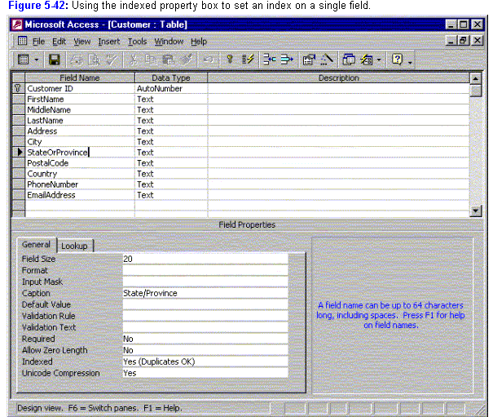
Creating an index on a single field in a table is easy. Open the table in Design view, and select the field for which you want an index—in this case, StateOrProvince. Click the Indexed property box in the lower part of the Table window, and then click the down arrow to drop down the list of choices, as shown in Figure 5-42.
When you create a table from scratch, the default Indexed property setting for all fields except the primary key is No. If you use the Table Wizard to create a table, the wizard indexes fields that might benefit from an index.
If you want to set an index for a field, Access offers two possible Yes choices. In most cases, a given field will have multiple records with the same value—perhaps you have multiple customers in a particular state or province or multiple books published in the same year. You should select Yes (Duplicates OK) to create an index for this type of field. By selecting Yes (No Duplicates) you can use Access to enforce unique values in any field by creating an index that doesn’t allow duplicates. Access always defines the primary key index with No Duplicates because all primary key values must be unique.
Note: You cannot define an index using a Memo or OLE Object field.

Multiple Field Indexes
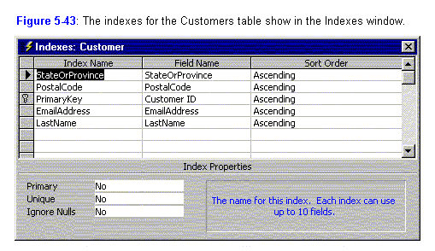
If you often provide multiple criteria in searches against large tables, you might want to consider creating a few multiple field indexes. This helps Access narrow the search quickly without having to match values from two separate indexes. For example, suppose you often perform a search for customers who have a particular last name, first name, and middle name. If you create an index that includes all of these fields, Access can satisfy your query more rapidly.
To create a multiple field index, you must open the Table window in Design view and open the Indexes window (shown in Figure 5-43) by clicking the Indexes button the toolbar or by choosing the Indexes command from the View menu. You can see the primary key index and the index that you defined on StateOrProvince in the previous section. Each of these indexes comprises exactly one field.
To create a multiple field index, move the cursor to an empty row in the Indexes window and type a unique name. In this example, you want a multiple field index using the LastName, FirstName, and MiddleName fields, so FullName might be a reasonable index name. Select the LastName field in the Field Name column of this row. To add the other fields, simply skip down to the next row and select another field without typing a new index name. When you’re done, your Indexes window should look like the one shown in Figure 5-44.
Note: You can remove an existing index by simply highlighting the row (by clicking the row selector) that defines the index and then pressing the Delete key. Any indexes you define, change, or delete are saved when you save the table definition.
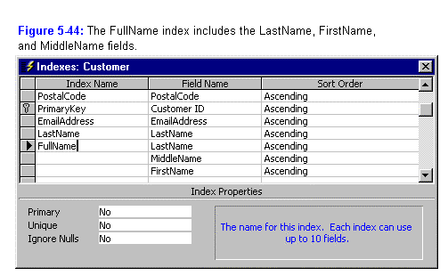
Access can use a multiple field index in a search even if you don’t provide search values for all the fields, as long as you provide search criteria for consecutive fields starting with the first field. Therefore, in the multiple field index shown in Figure 5-44, you can search for last name; for last name and first name; or for last name, first name, and middle initial. There’s one additional limitation on when Access can use multiple field indexes: only the last search criterion you supply can be an inequality, such as >, >=, <, or <=. In other words, Access can use the index shown in Figure 5-44 when you specify searches such as this:
LastName = “Smith”
LastName > “Franklin”
LastName = “Buchanan” And FirstName = “Steven”
LastName = “Viescas” And FirstName >= “Bobby”
But Access will not use the index shown in Figure 5-44 if you ask for
LastName > “Davolio” And FirstName > “John”
because only the last field in the search (FirstName) can be an inequality. Access also will not use this index if you ask for
FirstName = “John”
because the first field (LastName) is missing from the search criterion.
From Running Microsoft Access 2000 by John Viescas

Adding Indexes to Tables (From Using Access 97 by Roger Jennings)
Although Access creates an index on the Primary Key, you might want to create an index on some other field or fields in the table. Indexes speed up searches for records that contain specific types of data. You might want to find all personnel actions that occurred in a given time period and all quarterly review for all employees in paScheduleDate sequence, for example. If you have many records in the table, an index speeds up the searching process. A disadvantage of multiple indexes is that data entry operations are slowed by the time it takes to update the additional indexes. You can create as many as 32 indexes for each Access table, and five of those can be of the multiple-field type. Each multiple-field index can include as many as 10 fields.

